# Intro to Programming (Python)

Assignment 04

## Overview

In this activity, you will learn to work with for loops and tuples. Once again you will create your own scripts and document your knowledge. Your documents will be reviewed by your peers, so make your document and code look professional.

This assignment will include the following:

1. Watch the Module Videos:
2. Review the following web pages:
3. Watch the following videos:
4. Apply your knowledge
5. Document your knowledge
6. Submit your work.
7. Post your document
8. Perform a Peer Review

## Step 1: Watch the Module Videos

Please watch the following Module videos:

* <https://www.youtube.com/playlist?list=PLfycUyp06LG-pBmX3NqLG8ehmUhseoCNu> (Links to an external site)

## Step 2: Review the following web pages

Please review the following web pages. These are shorter than the book and provide online resources you can use later.

* <http://www.tutorialspoint.com/python/python_tuples.htm> (Links to an external site)

## Step 3: Watch the support videos

Please watch this video. It will explain things a bit differently, which helps with learning!

* <http://www.youtube.com/watch?v=R8mOaSIHT8U&feature=related> (Links to an external site)

## Step 4: Apply your knowledge

Now that you have reviewed the websites and videos, try to do the following task.

1. Create new program that asks the user for the name of a household item, and then asks for its estimated value. (This project is similar to the last one!)
2. Ask the user for new entries and stores them in the 2-dimensional Tuple.
3. Ask the user, when the program exits, if they would like to save/add the data to a text file called, HomeInventory.txt.

**NOTE**: Make sure you understand the following code sample...

strMoreData = ("4"), *#Note that the comma at the end makes this a tuple!!!*

tplData += strMoreData

## Step 5: Document your knowledge

Create a simple document to outline the steps you took in performing this assignment. Make sure the document is in a Microsoft Word document (.doc or .docx).

**NOTE**: *Make sure you put it in proper, college level, formatting!*

## Step 6: Submit your work

Now, place both your .doc or docx file and your python .py file into a folder called Assignment04 and zip the entire folder. Afterwards, upload the new zip file to the class assignment page.

## Step 7: Post your document

In this module, you need to post your document in the discussion forum so that others may review it. Just add your word document to the “Assignment 04 Documents for Review” discussion forum as shown in here:

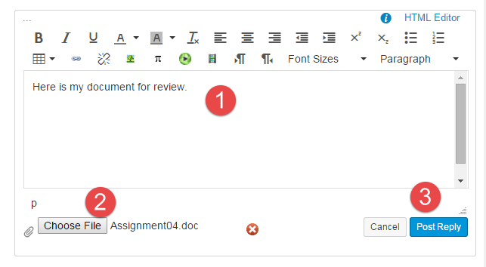

## Step 8: Perform a Peer Review

You will be randonly assigned a review parter by Canvas after the assignment due date. Please read the assignment turned in by this student and comment on the discussion forum.

* One thing that you liked about their paper
* One thing that could make the paper better

***You are done!***